**ONLINE PURCHASING SYSTEM**

**QUESTION:**

Draw a UML diagram for online purchasing system. Provide top level use cases for a web customer making purchases online. Web customer actor uses some web site to make purchases online. Top level use cases are View Items, Make Purchase and Client Register.

**AIM:**

To design a UML Use Case Diagram for an Online Purchasing System, identifying key interactions between the **Web Customer** and the system.  
**PROCEDURE:**

1. Identify actors: Web Customer, Payment Gateway, Admin

2. Define use cases: View Items, Make Purchase, Client Register, manage user account , see transaction limit, configure security, process payment.

3. Draw a UML diagram: Use ovals for use cases, stick figures for actors, and connect them with arrows.  
**DIAGRAM:**

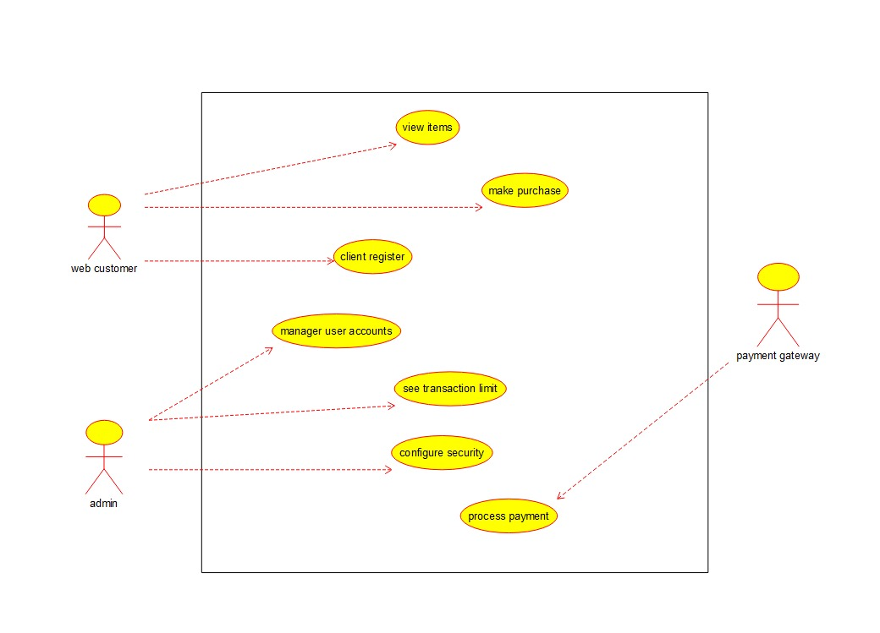

**RESULT:**A **Use Case Diagram** for the **WEB CUSTOMER’S** interaction with the online purchasing system was successfully created.